Robotics Process Automation Design and Development (UiPath) – BCG701 Lab
Experiment No: 6
Title: Develop Word automation in UiPath StudioX to demonstrate the following activities: Use Word File, Save Document As, Read Text, Replace Text in Document, Append Text, Replace Picture, Add Picture, Save Document as PDF.

Aim: To develop an automation in UiPath StudioX that demonstrates Word file automation by performing operations such as:
- Read Text
- Replace Text
- Append Text
- Insert Picture
- Export Document as PDF

Theory:
- Use Word File: Opens and manages a Word document within UiPath activities.
- Save Document As: Saves the current Word file with a new name or in a different location.
- Read Text: Reads all or part of the text in a Word file and stores it in a variable.
- Replace Text in Document: Finds and replaces specific text inside a Word file.
- Append Text: Adds new text to the end of the document.
- Replace Picture: Locates an existing picture in the document and replaces it with another image.
- Add Picture: Inserts a new image into the document.
- Save Document as PDF: Exports the Word document into PDF format.
Conduction:
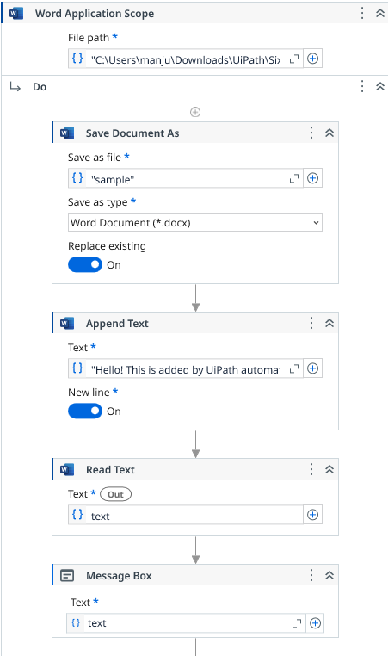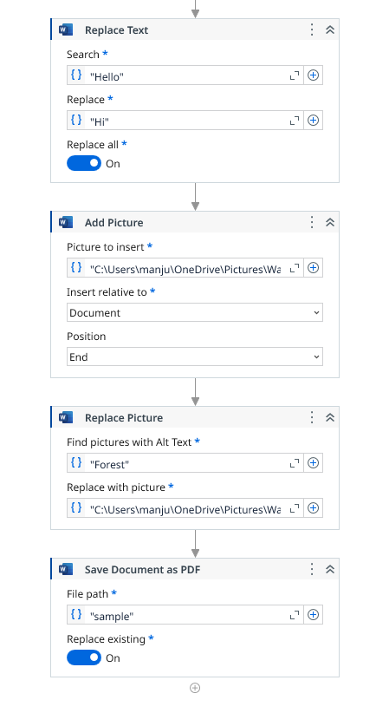

Output:
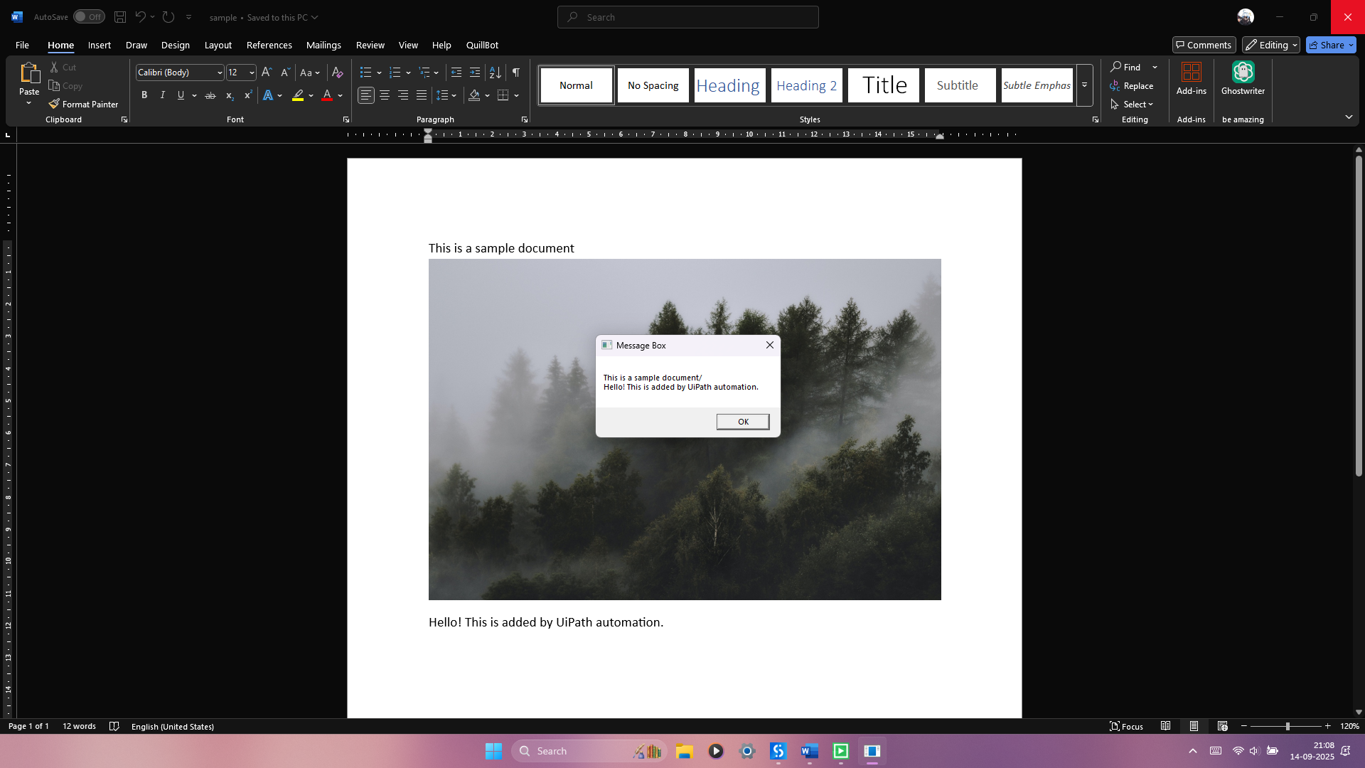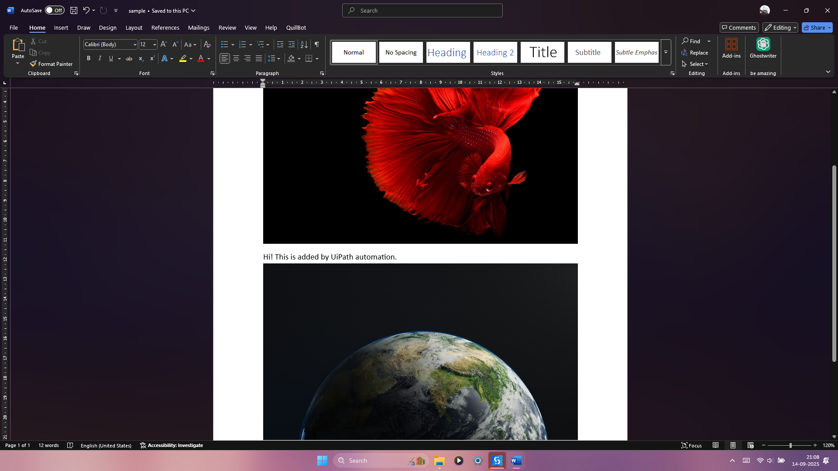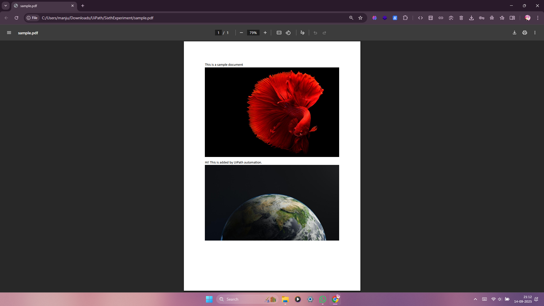
Observation and Results:
The following activities were successfully demonstrated in UiPath StudioX:
- Use Word File
- Save Document As
- Read Text
- Replace Text in Document
- Append Text
- Replace Picture
- Add Picture
- Save Document as PDF
The output for the above-mentioned activities is verified.

Evaluation:
Evaluation Parameters | Maximum Marks | Obtained Marks
Conduction | 8
Record Writing | 4
Viva | 3
Total | 15

Signature of the Faculty in-charge with date:

